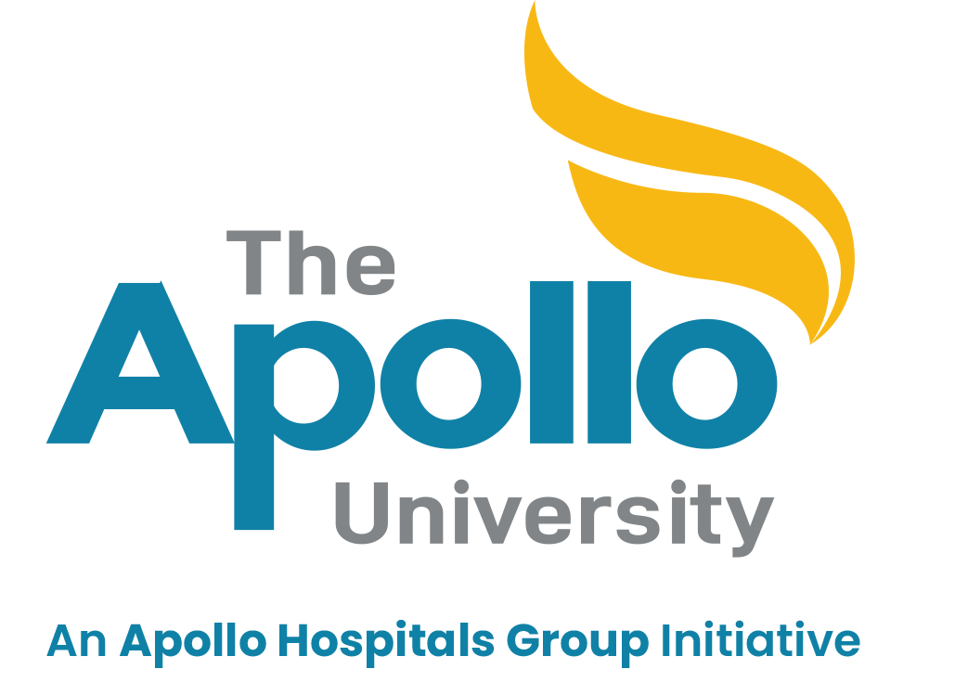
The Apollo University
The Apollo Knowledge City Campus,
Saketa, Murukambattu - Post, Chittoor - District,
Andhra Pradesh - State, India – 517127.
DEPARTMENT OF COMPUTER SCIENCE & ENGINEERING
B. Tech – CSE- IV/VI – Semester (2025-2026)
Internship Weekly Reporting Form

Sl.No. | Students Details
1 | Name of Student | B Sruthi
2 | Registration Number | 122411510118
3 | Department & Section/Year | cse-A/2nd year
4 | Title of Internship Project | Frontend Development Internship
5 | Name of the Guide | Akash Dubey
6 | Company/Organization Name | Alfido Tech
7 | Week Number | 7
8 | Reporting Period (Date) | From: 22/06/2026  To: 27/06/2026

Daily Work Report
Day | Date
  Description of Work Assigned/
  Tasks Completed / Learning Outcome
Monday | 22/06/2026 | Started the API Integration Project. Selected the REST Countries API, analyzed project requirements, planned the user interface, and created the project folder structure.
Tuesday | 23/06/2026 | Developed the basic layout using HTML5 and designed a modern, responsive interface using CSS3, including the navigation bar, search section, and responsive page layout.
Wednesday | 24/06/2026 | Implemented JavaScript Fetch API to retrieve country information dynamically. Added the search functionality and displayed country details such as flag, capital, population, region, languages, and currency.
Thursday | 25/06/2026 | Enhanced the application by implementing search suggestions, recent search history, dark/light mode, and favorites functionality using JavaScript and Local Storage.
Friday | 26/06/2026 | Added loading spinner, error handling for invalid searches, improved UI responsiveness, fixed JavaScript issues, and tested the application across different screen sizes and browsers.
Saturday | 27/06/2026
  Performed final debugging and testing, optimized the project, verified all features, prepared the project for GitHub repository upload and GitHub Pages deployment, and completed the project documentation.

B sruthi

Signature of Student

